**Name: Section:**

**Instructor:**

**Points: 100 TIME: 30 minutes**

**DIRECTIONS**

**DO NOT OPEN THIS BOOKLET UNTIL INSTRUCTED TO DO SO.**

**Authorized Resources**: Only the TI-30XIIS or TI-30XIIB calculator and CalcTool version 2.7.0a are authorized. You may not share authorized resources during the exam.

You have 30 minutes to complete this exam. Start / stop times will be written on the board.

Your work will be assessed based on *communicated proficiency* with the subject matter. In particular, your work should be well-executed, well-communicated, and essentially correct. **Supporting work required.**

**PROBLEM COURSE POINTS**

1-3 ________/ 55

4-6 ________/ 45

/ 100

**COURSE POINTS:**

ACADEMIC SECURITY: This examination is not to be released from academic security until 6 May, 1630. Until that time, you may not discuss the examination contents or the course material with anyone other than your instructor. ____

INTEGRITY: Your honor is extremely important. This academic security policy is designed to help you succeed in meeting academic requirements while practicing the honorable behavior our country rightfully demands of its military. Do not compromise your integrity by violating academic security or by taking unfair advantage of your classmates.  Cadets wanting to help each other study for the examination can only do so as long as none of the cadets studying together have taken the examination.______

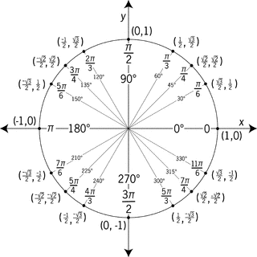

1. (20 points) Identify the correct integral to determine the length of the curve described by

$x=2ω^{3}-\frac{7}{2}$ and $y=2-\frac{8}{3}ω^{3}$ over the interval $-3≤ω ≤3$**.** Support your answer.

a.

b**.**

c.

d.

2. (20 points) Find the area for $r=2 sinϴ$ for $0≤θ≤\frac{π}{2}$. Support your answer.

note:

a.

b.

c.

d.

3. (15 points) If a child pulls a sled through the snow on a level path with a force of 40 N exerted at an angle of 30◦ above the horizontal, what are the horizontal and vertical components of the force? Support your answer.

Horizontal:

Vertical:

4. (10 points) Identify the Cartesian equation for the curve described by $x=e^{t}-1, y=e^{2t}.$

/ 55

Support your answer.

a.

b.

c.

d.

5. (15 points) Describe the path $x=6\sin\left(t\right), y=3\cos\left(t\right),$ $0≤t≤2π$.

a. Moves clockwise along the circle ${\left(6x\right)}^{2}+{\left(3y\right)}^{2}=1$ starting and ending at $\left(0, 3\right).$

b. Moves clockwise along the ellipse $\frac{x^{2}}{36}+\frac{y^{2}}{9}=1$ starting and ending at $\left(0, 3\right).$

c. Moves counterclockwise along the ellipse $\frac{x^{2}}{36}+\frac{y^{2}}{9}=1$ starting and ending at $\left(0, 3\right).$

d. Moves counterclockwise along the ellipse $\frac{x^{2}}{6}+\frac{y^{2}}{3}=1$ starting and ending at

6. (10 points) Write the equation for the sphere centered at (3, 7, 2) with radius 10.

(10 points) Is the point (3, -1, -4) located inside, on, or outside of the sphere?

Support your answer.

/ 45